Name and contact Details (include email and phone Number):  Email:  Mobile No.: | Billing name and address of User:
Department and Organization:
Advisor Name
Mask plate size (): 4”  Layer Name ( required ) and number: | For 4” mask plate, less than 2”x2” inch writing area preferred

DATA information (Select file format) -> | GDS-2 | CIF | Units (nm/µm/mm):
Note: Design needs to be provided in GDS or CIF format to avoid conversion errors
Layer Name | Mask Type* | Data centered |  | Mask |  |  | Structure on the design: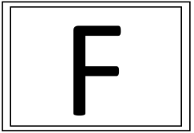
Layer Name | A or B | Yes | No** | Critical Dimension  ( Location)# | Smallest Dimension; +/- Tolerance | Largest Dimension; +/- Tolerance
A
B

* Mask type | A = Chrome up, Data Dark (Inversion/Bright Field Mask)
* Mask type | B = Chrome up, Data clear (Non Inversion / Dark Field Mask)
** if not centered specify the data window  (total design window) | X direction:  Diagonal X: |  | Y direction:  Diagonal Y:
# For inspection: Critical dimension Location (specify the coordinates) | X: |  | Y:
 | X: |  | Y:
 | X: |  | Y:
 | X: |  | Y:
 | X: |  | Y:

Signature of the USER

Important notes:
- Minimum Critical Dimension/ spacing offered by CNNP is 3um.
- Side wall/edge roughness ~ 200nm (also depends on the design)
Default writing Is Non-Inversion mode (if you don’t specify) i.e., Colored portion in your design will be transparent on the mask and Mask will be written as per the design submitted (CNNP will not do any design conversion like XOR, OR, AND or Flipping).
- Defect densities of the order of 1 defect per square inch is expected in the mask writing
(Masks with 98% defect free areas can be achieved)
- Design rule:
  - Boolean operations such as OR, XOR, flipping, subtract, invert, merge etc., should be done by the user before submitting the design.
  - Alignment marks should be symmetric with respect to all the layers in the design. (i.e., for multi layers.) And should be added before submitting the design.
  - If Back Side Alignment is involved, please specify the layer number and description
  - Flatten the design before submitting.
  - Maximum file size should not exceed 20 MB.
Photomask tolerance and inspection details:
(The below tolerances will be used unless otherwise specified on Mask Order Form)
Photomask critical and dimension tolerance specification
Dimension | Tolerance
≤ 5um | +/- 500 nm
5 to 10um | +/- 500 nm
10 to 50 | +/- 1 µm
50 to 100 | +/- 1 µm
>100 | +/- 2 µm
Note: Any specific inspection required kindly mention here with ref. to table.
Hereby, I have thoroughly gone through the above-mentioned details, and I have provided correct information for mask fabrication.

Signature of the USER

ANNEXURE
Example of photomask layout and exposable area:
Typical 4-inch Mask & 2”x2” Exposable area (Now Maximum preferable)
Dead area
Mask area
Alignment area

Design to mask tolerance
Provide structure on design | Expected on mask
Sharp edges on the design | Rounded off In the mask
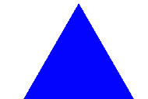  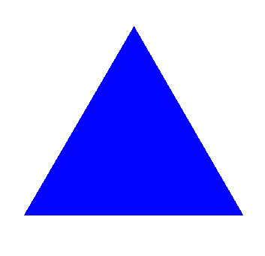  Sharp edged on the design | 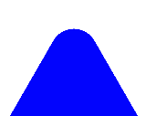  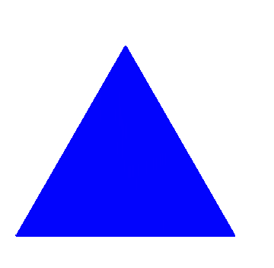  less than 3um (Critical dimension) will get rounded off (blunt edges) in Photomask

